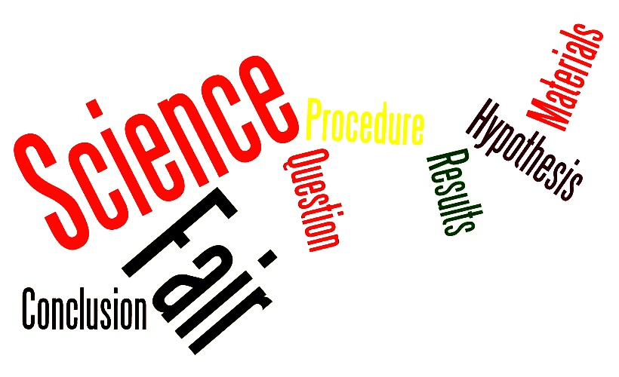
Name: _______________

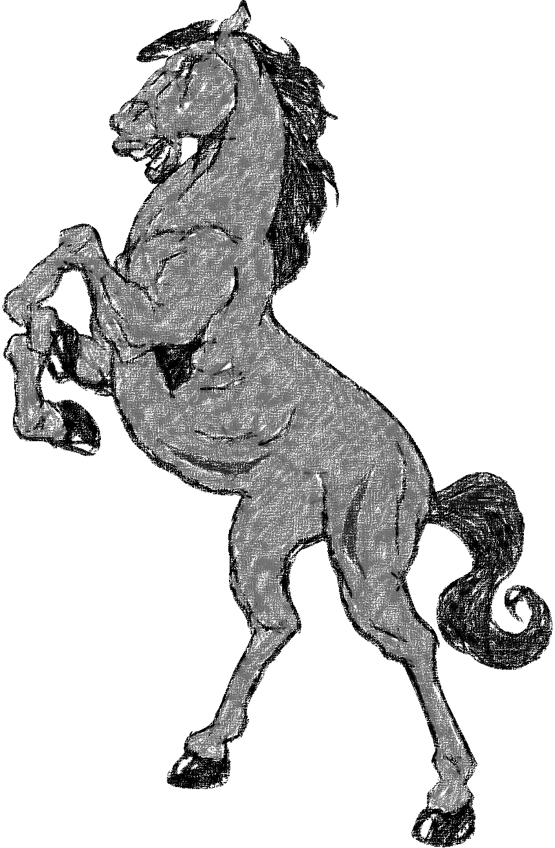

Included in this packet:

- Information about the upcoming science fair

- Directions on what you’ll need to do

- A scoring rubric telling you how your project will be graded

- Your science fair proposal

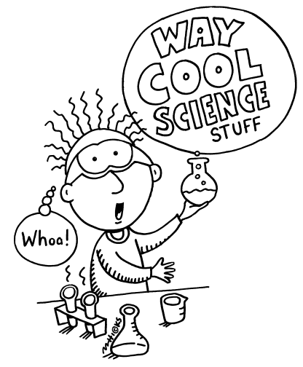
Good Hope Elementary Science Fair

What is the Science Fair?
A Science Fair is a competition of student science projects held each year at your school, in your district, in your county, and in the state of California.

What is a science project?
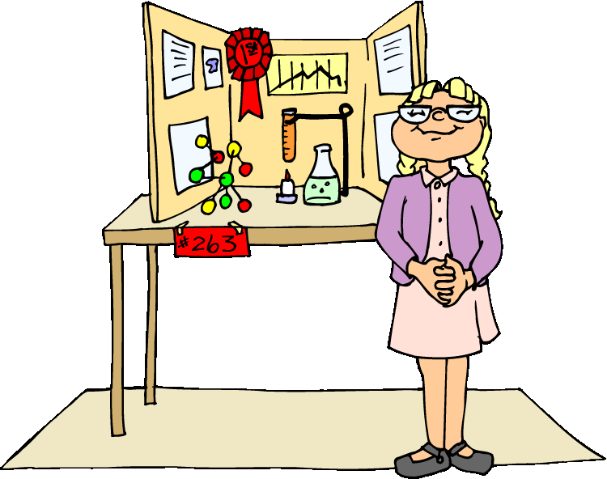
A science project is the active “fun” approach to science! It is an investigation of a question about a science topic that interests you. The difference between this kind of project and other ways of working on a problem is the use of a systematic plan called the Scientific Method.

What is the Scientific Method?
The Scientific Method is a way of working on a problem using a series of related steps.

Step 1: Identify and state the problem (usually as a question) and purpose of the investigation.

Step 2: Research your question and find out what is known about the problem from reading and by talking with experts. You can use the internet, encyclopedias, books, or conduct an interview.

Step 3: Using your research and prior knowledge, form a hypothesis- what do you think will happen in your investigation.

Step 4: Plan an experiment that will test your hypothesis. Describe how you will complete the
experiment (your procedure). Don’t forget to list your materials you will use throughout your experiment.

Step 5: Do the experiment. Record all information, observations, and measurements in a
notebook or journal. Display your data in graphs or chart.

Step 6: State your conclusions. Tell what happened in your experiment and if it proved or disproved your hypothesis. Most importantly, write about what you learned using complete sentences.

Basically, your science project has three parts.

- Start with writing a PROPOSAL: This is the Orange form attached to the back of this packet. This identifies the problem this project will address, the process you will follow and the solution you hope to reach. The proposal MUST BE APPROVED by your teacher before you can move forward on your project. Your proposal is due on ___________.

- Next, get started on your NOTEBOOK/ DAILY JOURNAL: You will start this once your proposal is approved. The purpose of the journal is to record your thoughts, ideas, questions, and experiences throughout your experiment. Much of what we know about Albert Einstein (One of the world’s most famous scientists in history) came from reading his journals. You may use a spiral notebook or the one provided for you in this packet. Attach your journal to your science project display board on the day your project is due.

- Finally, start building your DISPLAY: Your display board should show your understanding and application of the Scientific Method. It should also be eye-catching, attractive, neat, and accurate. When adding photos, please DO NOT include faces of people in the pictures.
Your teacher will use the rubric below to assign you a grade for your science project. The project itself will receive a grade, as will the presentation. The three most important things that will be judged are completeness, quality of your journal, and whether or not your conclusion/results addressed your problem.
