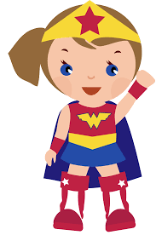
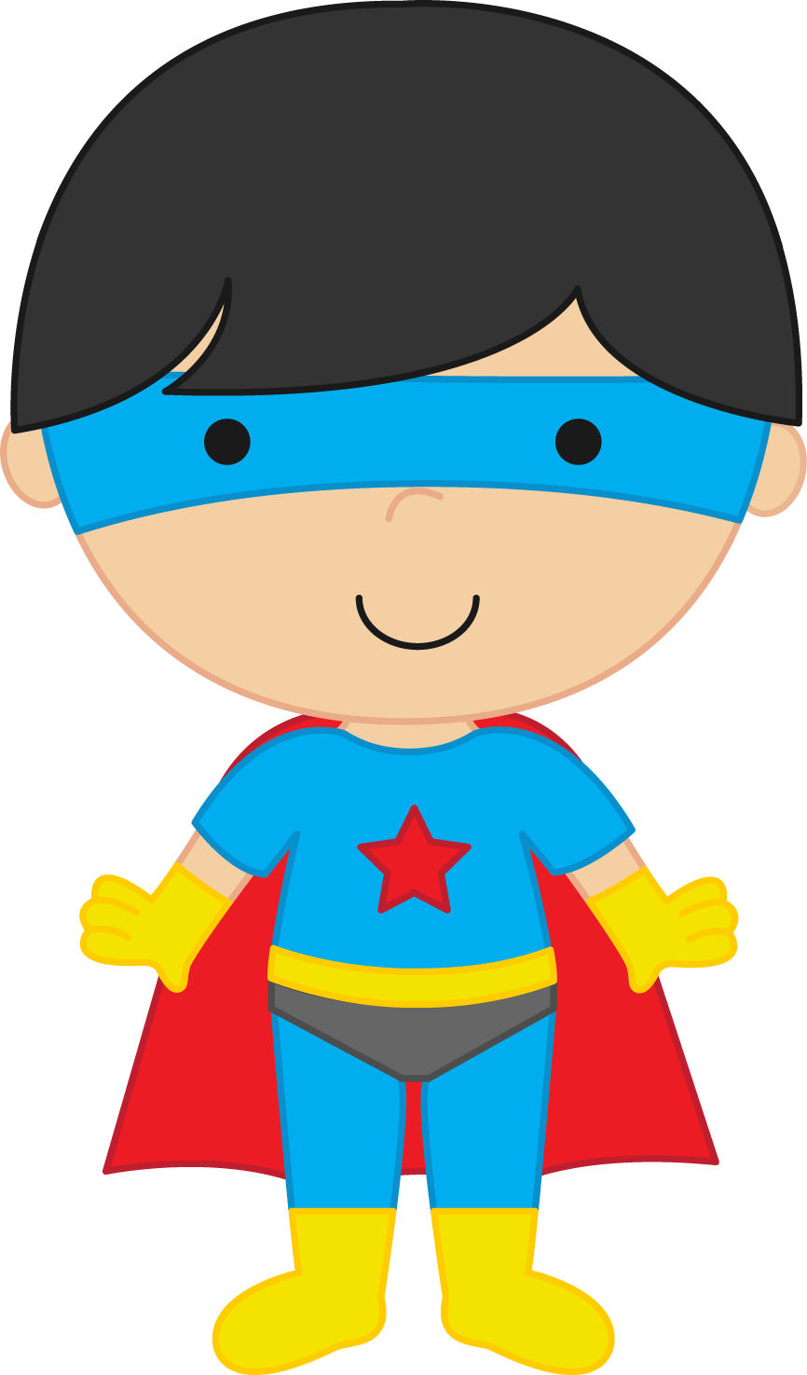
Be Responsible
Be Respectful
Be Safe

Follow directions the FIRST time given
Keep hands, feet, and all objects to yourself
Do your BEST to learn
Be NICE!

Consequences
Warning/reminder
Review of PBIS expectation(s)
Time out (possibly in another class) with PBIS reflection
Low Level Referral with parent contact
Office Referral and parent contact

All MAJOR offenses will be sent directly to the Office.

