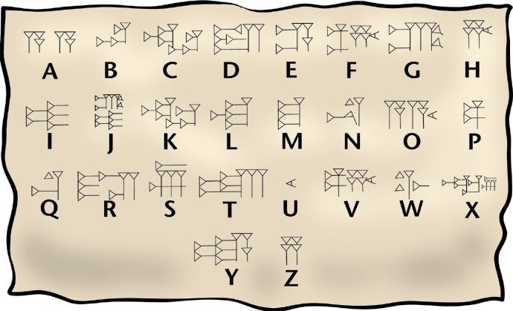

The earliest writing systems evolved independently and at roughly the same time in Egypt and Mesopotamia, but current scholarship suggests that Mesopotamia’s writing appeared first. That writing system, invented by the Sumerians, emerged in Mesopotamia around 3500 BCE. At first, this writing was representational: a bull might be represented by a picture of a bull, and a pictograph of barley signified the word barley. Though writing began as pictures, this system was inconvenient for conveying anything other than simple nouns, and it became increasingly abstract as it evolved to encompass more abstract concepts, eventually taking form in the world’s earliest writing: cuneiform. An increasingly complex civilization encouraged the development of an increasingly sophisticated form of writing. Cuneiform came to function both phonetically (representing a sound) and semantically (representing a meaning such as an object or concept) rather than only representing objects directly as a picture.

